SEO Recommendations –

- Content not Found:- Text to HTML Ratio is 5%. Your website's ratio of text to HTML content is below 10 percent. This is an indication that your site is very code heavy and complex, making it harder for search engines to identify user content. Need to add unique and informative (SEO Friendly) content on the homepage as well as inner pages of the website. Please find separate file for web content requirement.
Remarks - Started working on this and sent to the client, waiting for the approval.

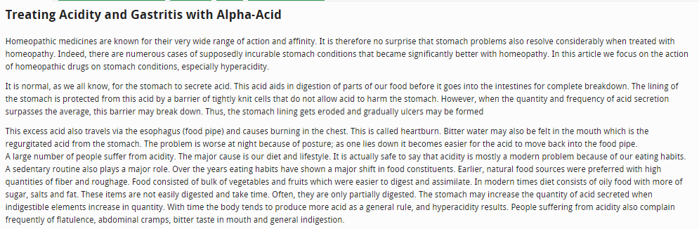

- Heading Tags:- HTML header tags (or simply header tags) differentiate between headings, subheadings and the rest of the content on the page. Sblglobal.com currently has 0 HTML header tags. Each page should have one, and only one, <H1> tag. Use keywords in your headings with your most important keywords in the top level, and be sure to maintain the <H1> to <H6> hierarchy.
Remarks - Pls refer to the whatsapp message Date & Time - 20/02/2025, 15:56 PM
- Footer Optimization:- Footer is not optimized properly. We can add physical address with hCard, important links, social links and other stuff on the footer part of the website. Need to add below target pages in the footer section of the website.

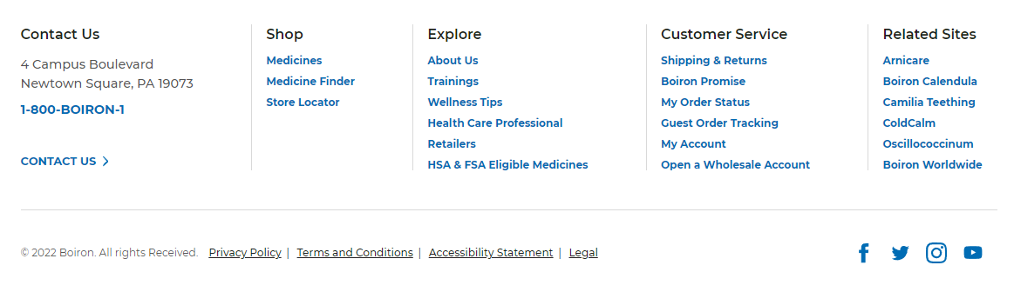
Below are the target pages which can be add on the footer section:
  - https://sblglobal.com/product
  - https://sblglobal.com/product/baby-care
  - https://sblglobal.com/product/bio-chemics
  - https://sblglobal.com/product/bio-combination
  - https://sblglobal.com/product/dilutions
  - https://sblglobal.com/product/eye-ear-drop
  - https://sblglobal.com/product/hair-care
  - https://sblglobal.com/product/herbals
  - https://sblglobal.com/product/hygiene-care
  - https://sblglobal.com/product/liquid-specialities
  - https://sblglobal.com/product/lm-potency-dilutions
  - https://sblglobal.com/product/mother-tinctures
  - https://sblglobal.com/product/ointments
  - https://sblglobal.com/product/oral-care
  - https://sblglobal.com/product/skin-care
  - https://sblglobal.com/product/tablet-specialities
  - https://sblglobal.com/product-details/montana-herbal-shampoo-combo
  - https://sblglobal.com/product-details/montana-herbal-shampoo-conditioner-combo
  - https://sblglobal.com/product-details/prostonum-drops-1688
  - https://sblglobal.com/product-details/kalmegh-drops-1678
  - https://sblglobal.com/product-details/alfalfa-tonic-with-ginseng-1323-1668

- Call To Action:- For making website user friendly, need to add Call to Action section (Email id, Phone No etc..) on header of the website.
Remarks - Waiting for the client’s approval.

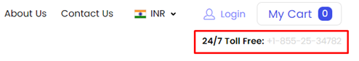
- Website Speed is 16/100 on Mobile:- Nearly half of all visitors will leave a mobile site if the pages don’t load within 3 seconds. It looks like Sblglobal.com is slow on mobile phones. Unfortunately, most people won’t wait very long before leaving a slow-loading site and tapping somewhere else.
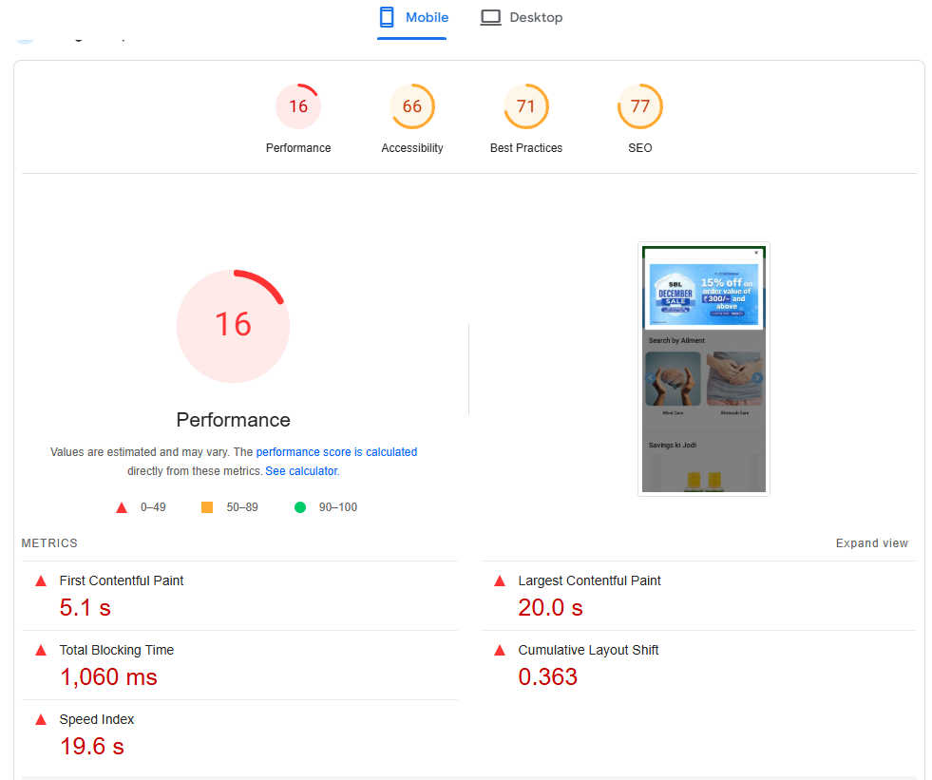

- Website Speed 7/100 on Desktop:- It looks like Sblglobal.com is slow on laptops and desktop computers. In today’s world, people expect an instantaneous response—any delay can cause them to click to another site
Remarks - As tested on different browsers and different devices the speed of the website looks perfectly fine. There are some scripts which are added to the website for SEO pupose and the tools suggesting to remove the scripts so as such the speed is not bad, you can also test it, it loads quickly

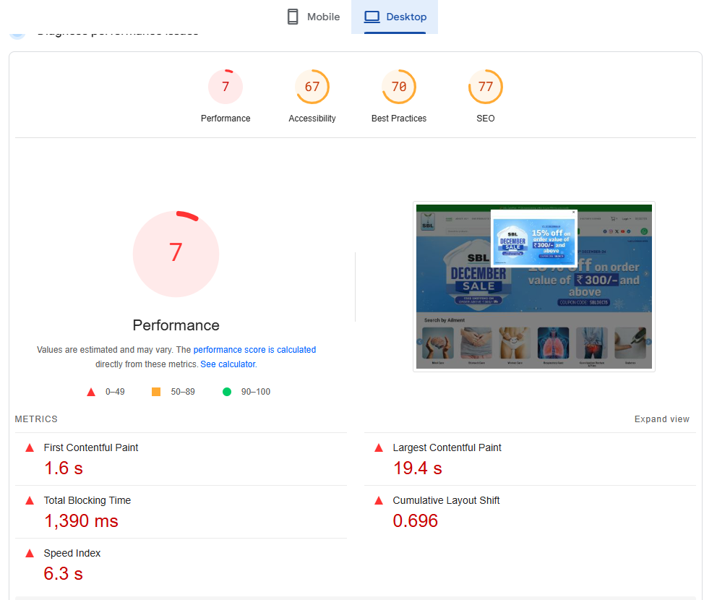

- Inter-Linking:- URL inter-linking of the website is not good. Internal links confer several SEO benefits. When search engine spiders find your site they follow links to discover additional pages on your site. They follow these link webs so that they can discover and archive as many relevant pages as they can on one visit. It helps organize the content on your site and helps visitors find information quickly. Need to inter-link all URL’s with header and footer section of the website.

- ALT Tags Missing:- Alternative text allows you to add a description to an image. Since search engine crawlers cannot see images, they rely on alternative text attributes to determine relevance to a search query. Alternative text also helps makes an image more likely to appear in a Google image search and is used by screen readers to provide context for visually impaired users. It looks like you're missing alternative text for 197 images on sblglobal.com. Check the images on your website to make sure accurate and relevant alternative text is specified for each image on the page.

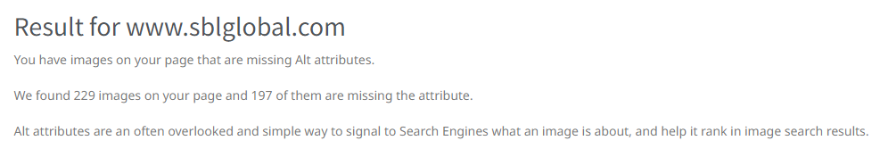

- Missing FAQs on Landing Pages: The purpose of a FAQ is generally to provide information on frequent questions or concerns; however, the format is a useful means of organizing information, and text consisting of questions and their answers may thus be called a FAQ regardless of whether the questions are actually frequently asked. We suggest you to add FAQ on each and every category or product pages.
Remarks - From development side the functionality is added on both sides i.e frontend and backend, the content part is pending.
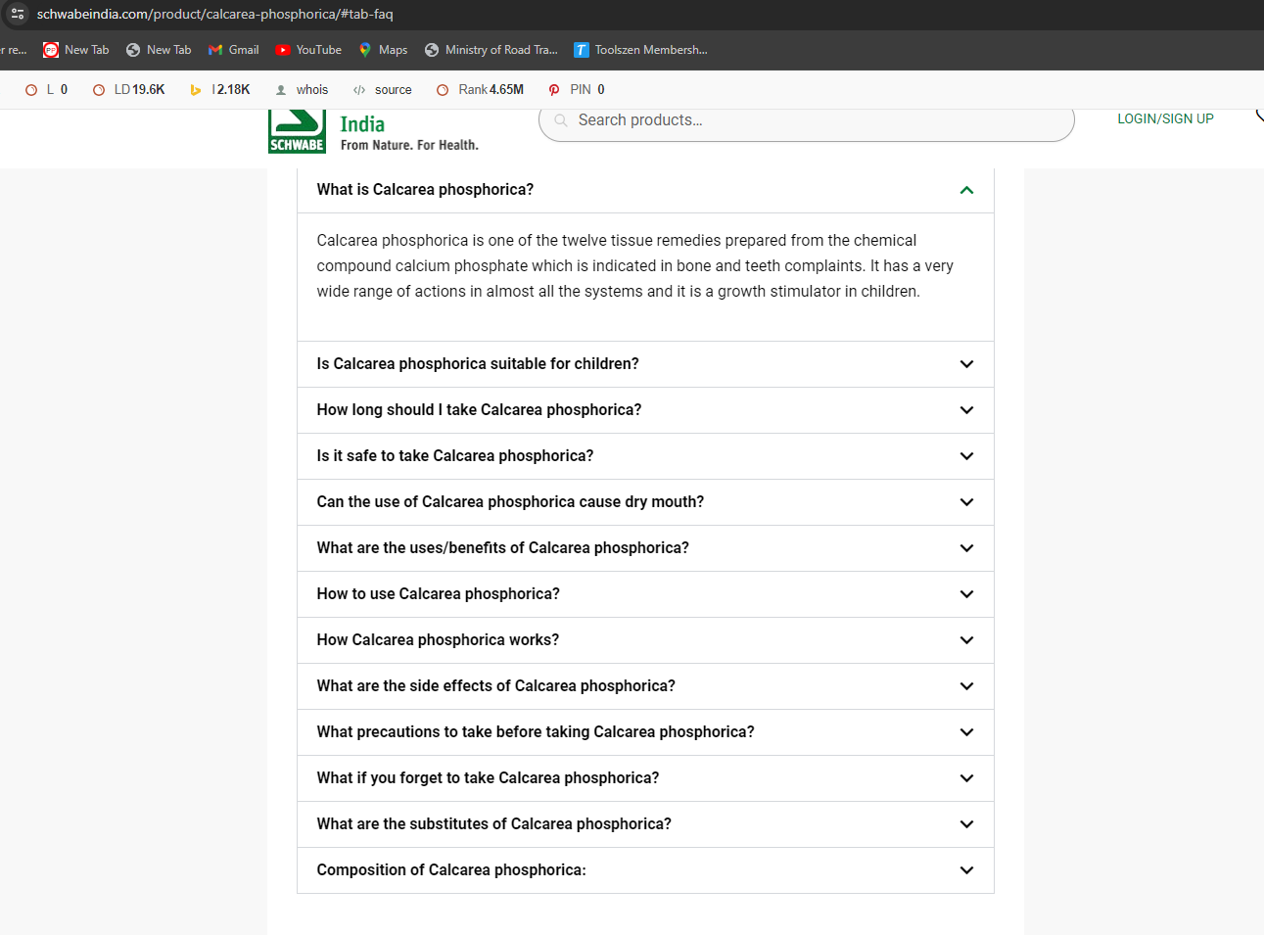

- URL Structure:- Some URL Structure of website is not user and search engine friendly. Its need to make user and search engine friendly URL. It’s should be

It’s should be https://sblglobal.com/products/homepathic/liquide-spacilist/nixocid-syrup-sugar-free instead of https://sblglobal.com/product-details/nixocid-syrup-sugar-free-115ml
Need to follow same with all the products pages.

Make sure OLD pages should be redirect on new pages after changes URL structure.
Remarks - We have provided the development link to the client for the approval once client will approve, we will make the changes live.

